3rd ANNUAL
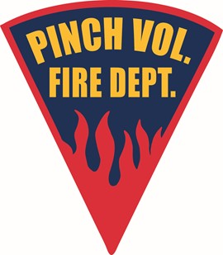
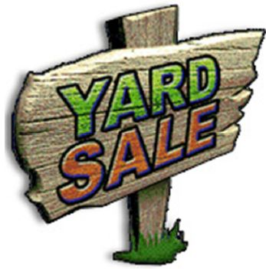 & 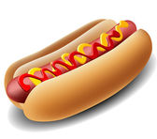
7 AM-2 PM
Rain or shine
HOT DOG SALE @ 10:30 AM

SATURDAY
RESERVE YOUR SPOT BY VISITING OUR WEBSITE WWW.PINCHFIRE.COM OR FOLLOW OUR FACEBOOK PINCH VOLUNTEER FIRE DEPARTMENT
MAY 7TH 2022
231 N. Pinch rd
Pinch main station activity field
YARD SALE SPOTS (12’X12’): $10.00/ SPOT (nonrefundable)
VENDOR/BUSINESS SPOTS (12x12): $20.00/SPOT (nonrefundable)
LIMITED TABLES AVAILABLE: $10.00/ TABLE (nonrefundable)

